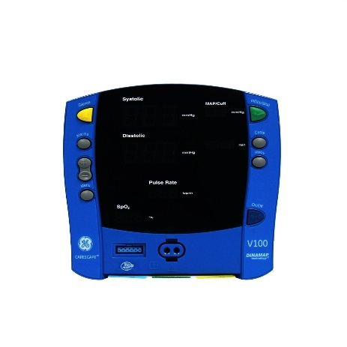
GE CARESCAPE V100 DINAMAP VITAL SIGNS MONITOR
ACCESSORIES INCLUDE:
- GE CRITIKON BP cuffs
- SP02 Sensors

WEIGHT | 10.0 LBS
NIBP | SuperSTAT, Auscultatory, Classic
WIRELESS CAPABILITY? | No
SPO2 | Ohmeda TruSignal, Nellcor, or Masimo
CONDITION | RECERTIFIED

