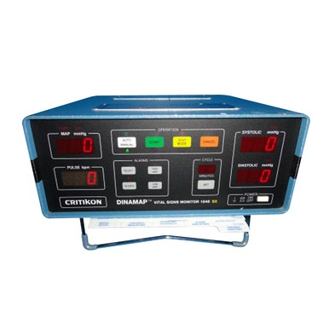
GE CRITIKON DINAMAP 1846 SX VITAL SIGNS MONITOR
ACCESSORIES INCLUDE:
- GE CRITIKON BP cuffs
- SP02 Sensors

WEIGHT | 10.0 LBS
MEASUREMENTS | 14”H x 10’W x 14” D
WIRELESS CAPABILITY? | Yes
SPO2 | Nellcor
CONDITION | RECERTIFIED

